

**DEPARTMENT OF ELECTRICAL AND ELECTRONICS ENGINEERING**

**(2023-2024)**

**Internship and mini project based on python programming with Data Engineer**

**Project title**

**Scholastic achievement**

**In**  **accordance with requirement of degree of**

**BACHELOR OF TECHNOLOGY**

**In**

**ELECTRICAL AND ELECTRONICS ENGINEERING**

**Submitted by:**

**CH.JAHNAVI**

**21KQ1A0202**

**Date: 11-06-2024**

PROJECT TITLE

SCHOLASTIC ACHIEVEMENT

Abstract:

Scholastic achievement analytics integrates various data sources, including academic records,test scores,student learning pattern and outcomes underscores its significantes in driving eductional excellence and student success totally how the records should be calculated scholastic achievement analytics include identifying at-risk students, it defines the over view of the total marks, minimum marks and maximum marks with corresponding reqirments it detemine the marks of every student.along with highest and lowest marjks with their significates of the student response.

Description:

A scholastic achievement analyst is a professional who assesses and analyzes academic performance, typically within an educational institution. Their role involves collecting, interpreting, and presenting data related to student achievement in various subjects or areas of study.

Data Collection: They gather information on student performance through various means, such as standardized test scores, classroom assessments, attendance records, and teacher evaluations.

identify patterns, trends, and areas for improvement in academic performance. This analysis may involve comparing student performance across different demographics, identifying strengths and weaknesses in the curriculum, or evaluating the effectiveness of teaching methods.

Collaboration: Scholastic achievement analysts often collaborate with educators, administrators, and other stakeholders to interpret data and develop strategies for Data Analysis: Using statistical techniques and software, they analyze the collected data to improving student outcomes. This collaborative approach ensures that their analyses are grounded in the realities of the educational environment and are effectively implemented.

Communication: They communicate their findings and recommendations clearly and effectively to various audiences, including educators, parents, and policymakers. Strong communication skills are essential for translating complex data into actionable insights that can drive positive change in education.

Continuous Learning: To stay abreast of the latest trends and best practices in education and data analysis, scholastic achievement analysts engage in ongoing professional development and training. This enables them to adapt their methods and approaches to evolving educational needs and challenges.

Overall, scholastic achievement analysts play a crucial role in helping educational institutions understand and improve student performance through data-driven decision-making.

Requirements:

Becoming a scholastic achievement analyst typically requires a combination of education, skills, and experience. Here are the typical requirements:

Education: A bachelor's degree in education, statistics, psychology, educational psychology, data analysis, or a related field is often required. Some positions may prefer candidates with a master's degree or higher, especially for more advanced or specialized roles.

Analytical Skills: Strong analytical skills are essential for interpreting complex data sets related to student achievement. Candidates should be proficient in statistical analysis methods and software, such as SPSS, SAS, R, or Python, and have the ability to draw meaningful insights from data.

Knowledge of Education Systems: A solid understanding of educational principles, curriculum development, and assessment techniques is necessary to effectively analyze scholastic achievements. Familiarity with educational standards and policies is also beneficial.

Communication Skills: Excellent written and verbal communication skills are essential for conveying analytical findings and recommendations to diverse audiences, including educators, administrators, policymakers, and parents. The ability to present complex information in a clear and understandable manner is crucial.

Critical Thinking: Scholastic achievement analysts must possess strong critical thinking skills to identify patterns, trends, and areas for improvement in academic performance. They should be able to evaluate data objectively and propose evidence-based solutions to enhance student outcomes.

datasets and conducting statistical analyses. Even minor errors or discrepancies in data Attention to Detail: Paying close attention to detail is essential when working with large collection or analysis can significantly impact the accuracy of findings.

Collaboration and Teamwork: The ability to collaborate effectively with educators, administrators, and other stakeholders is important for developing strategies to improve.

Approach:

Improving scholastic achievement requires a comprehensive approach that addresses various factors influencing student performance. Here's a multi-faceted approach for enhancing scholastic achievement:

Data Analysis and Assessment,Curriculum and Instructional Design,Student Support Services,Parent and Community Engagement,Technology Integration,Social and Emotional Learning (SEL),Continuous Improvement and Accountability By adopting a holistic approach that addresses the academic, social, and emotional needs of students, schools can create an environment where all students have the opportunity to thrive and achieve their full potential.

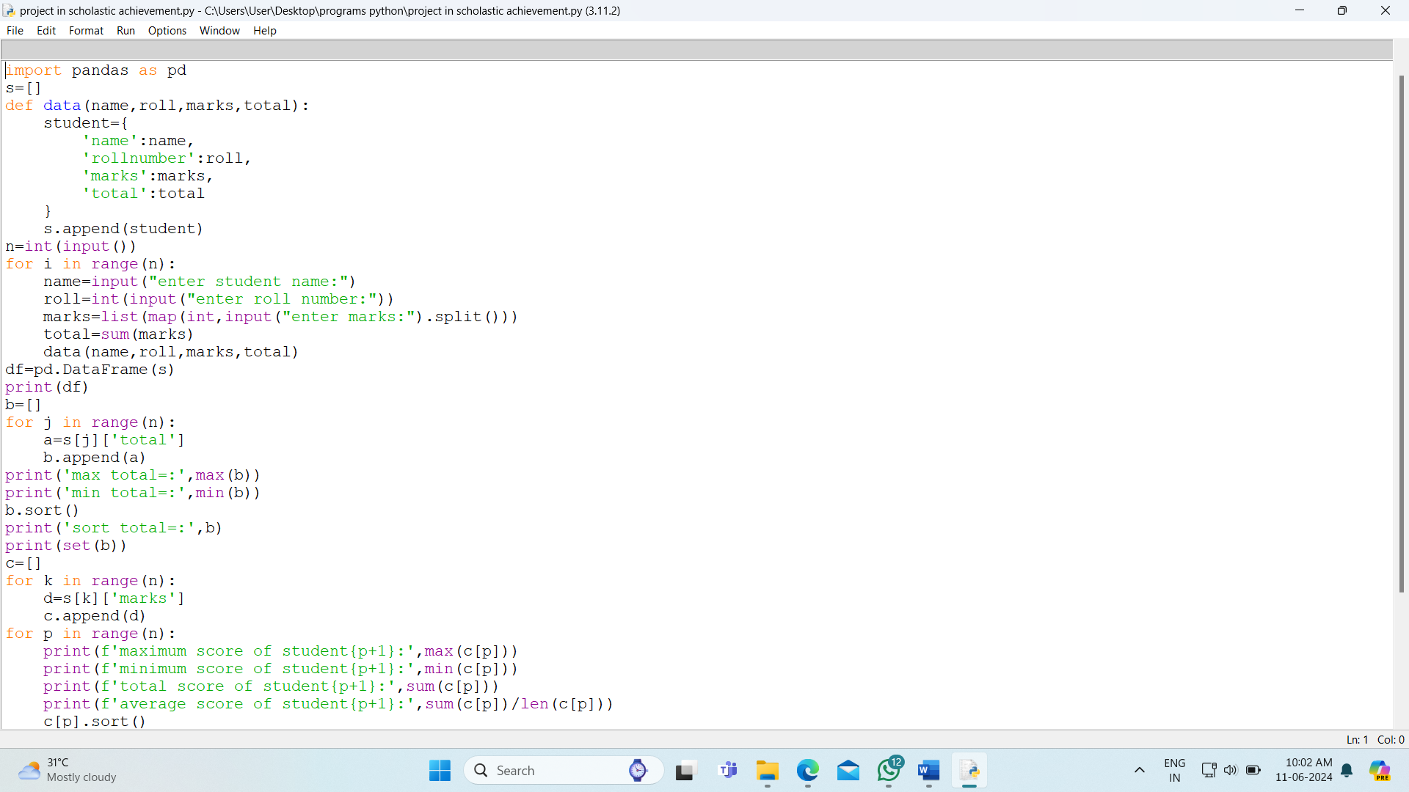

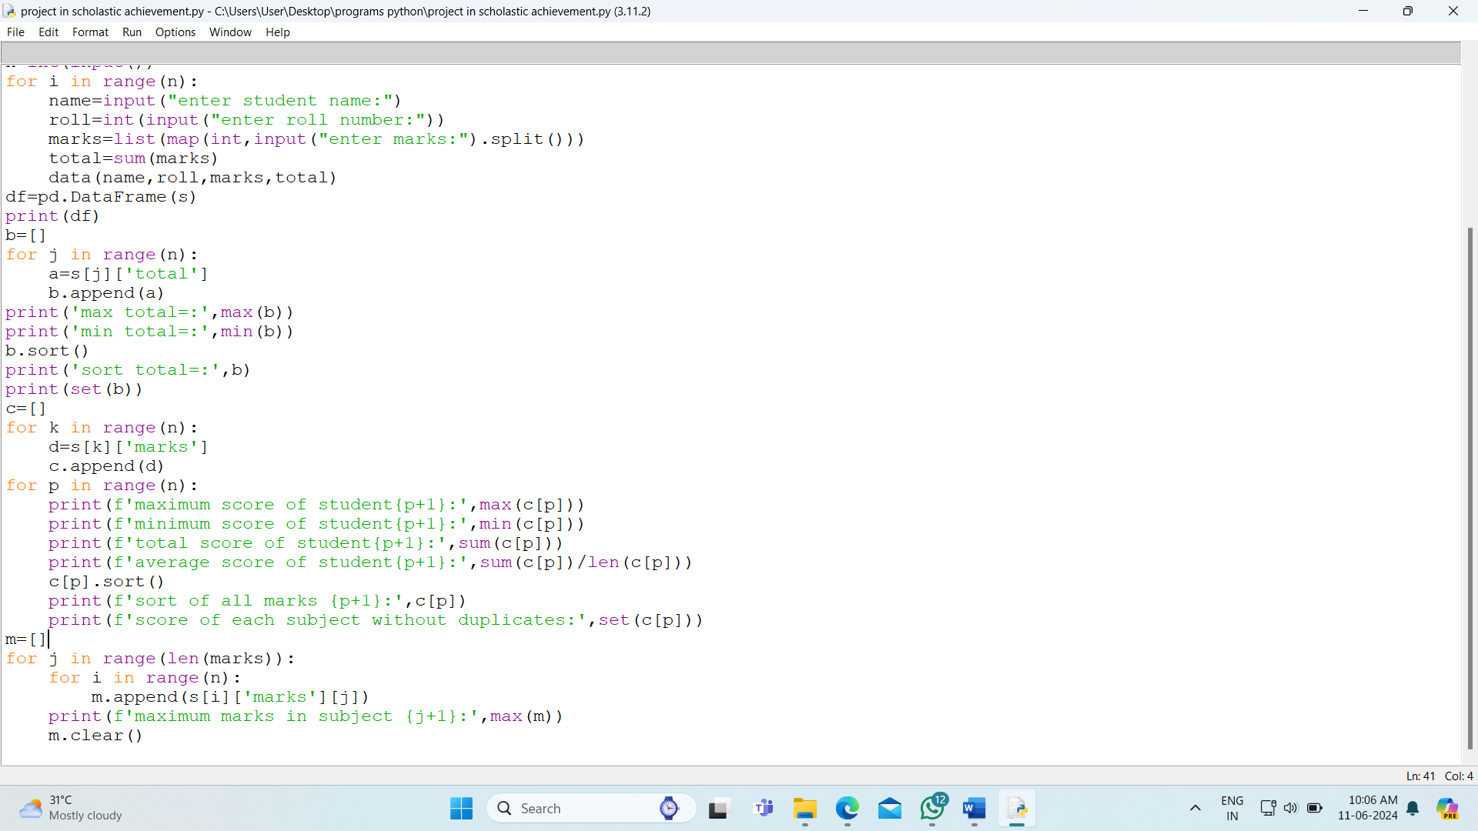

Output:

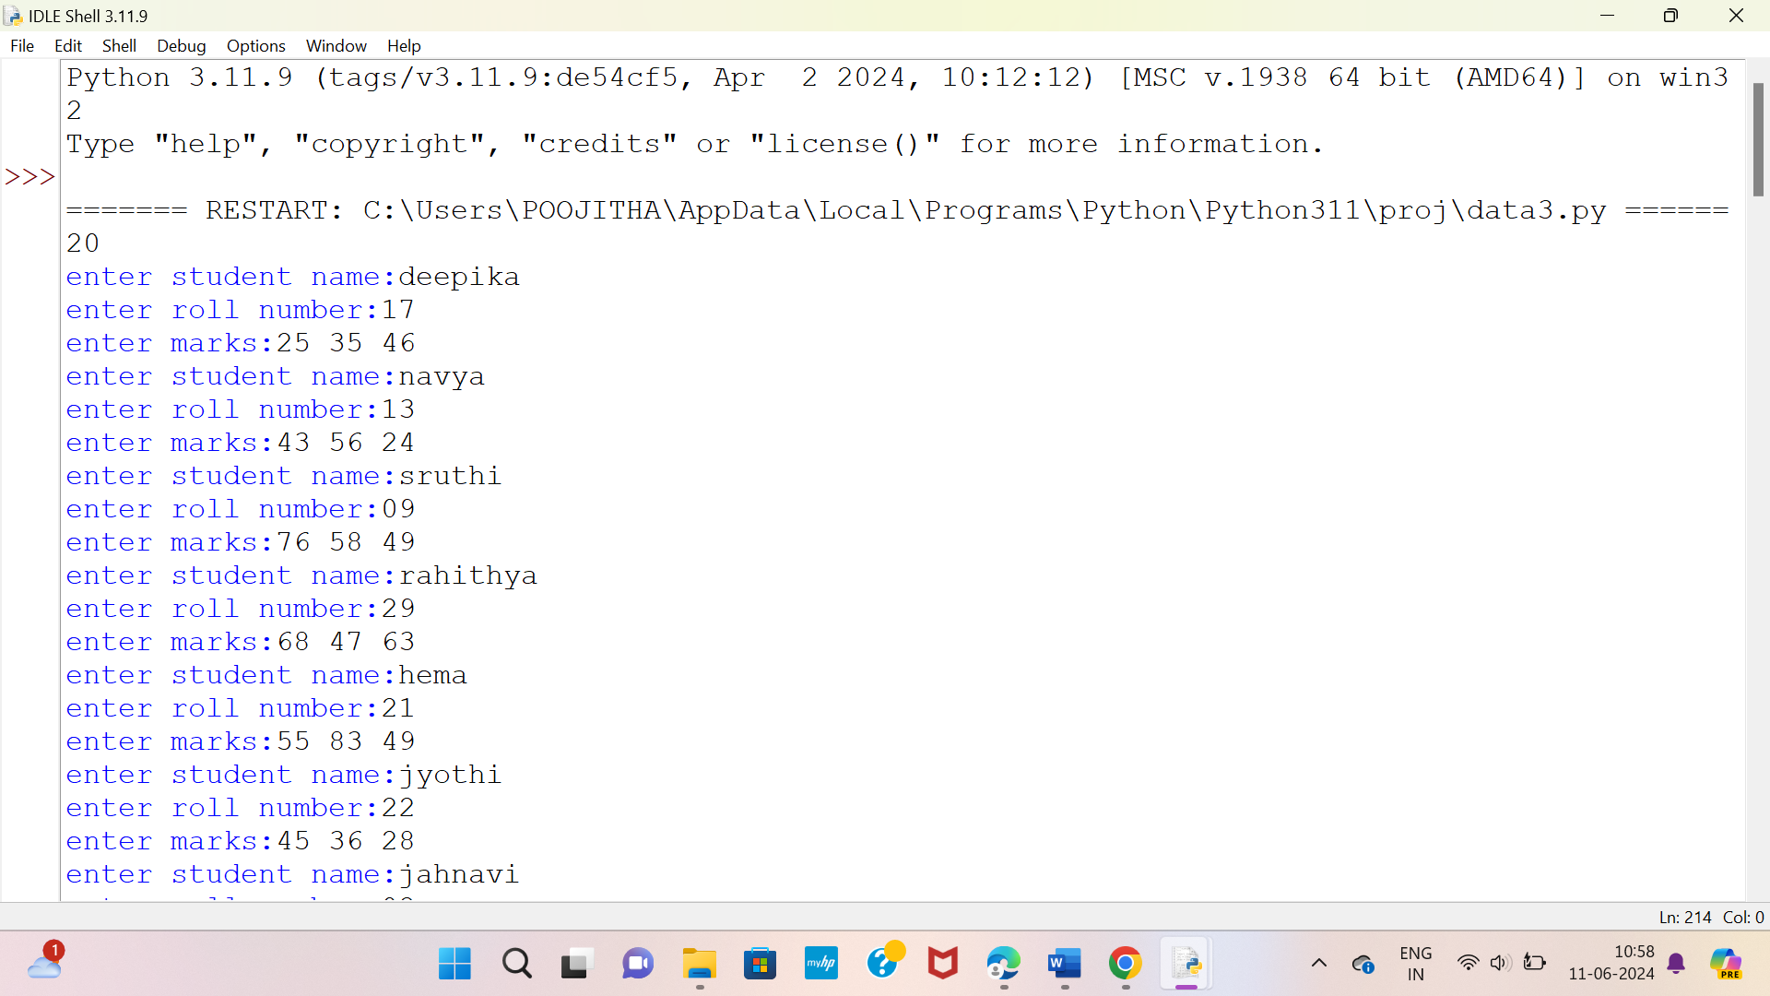

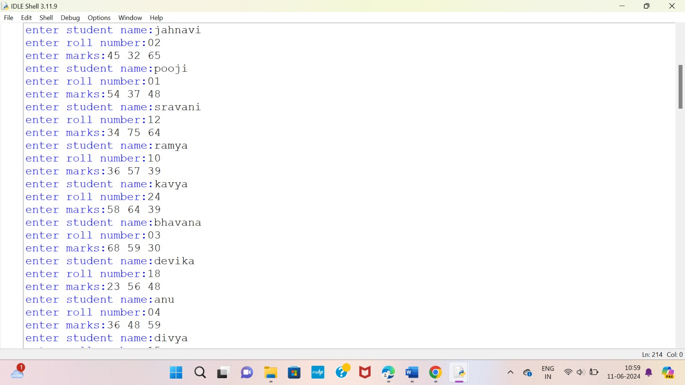

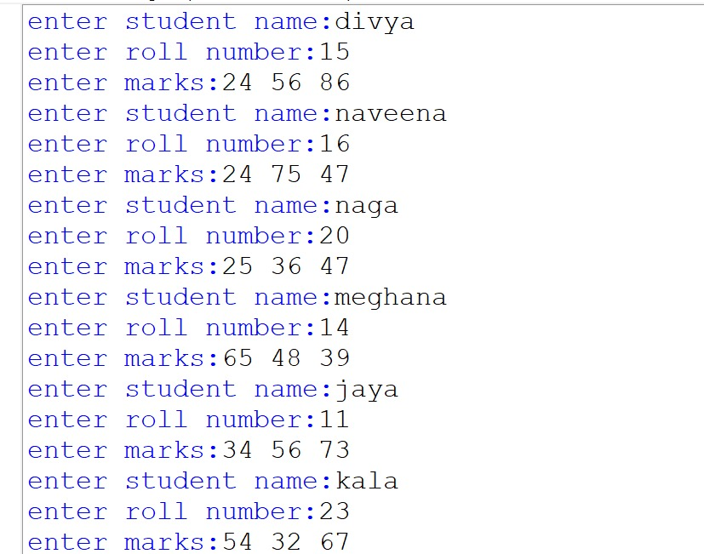

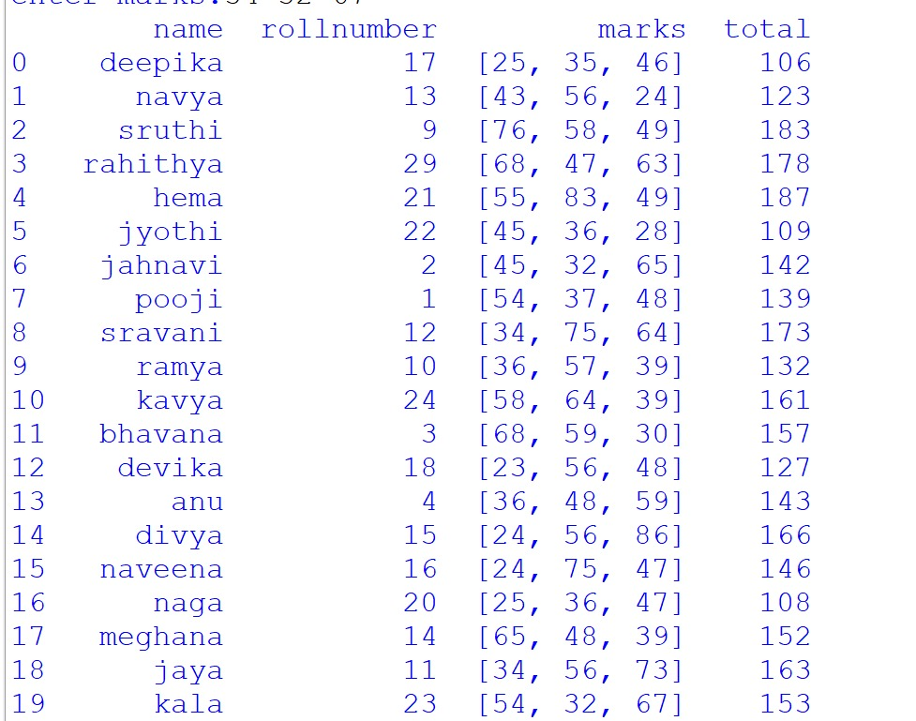

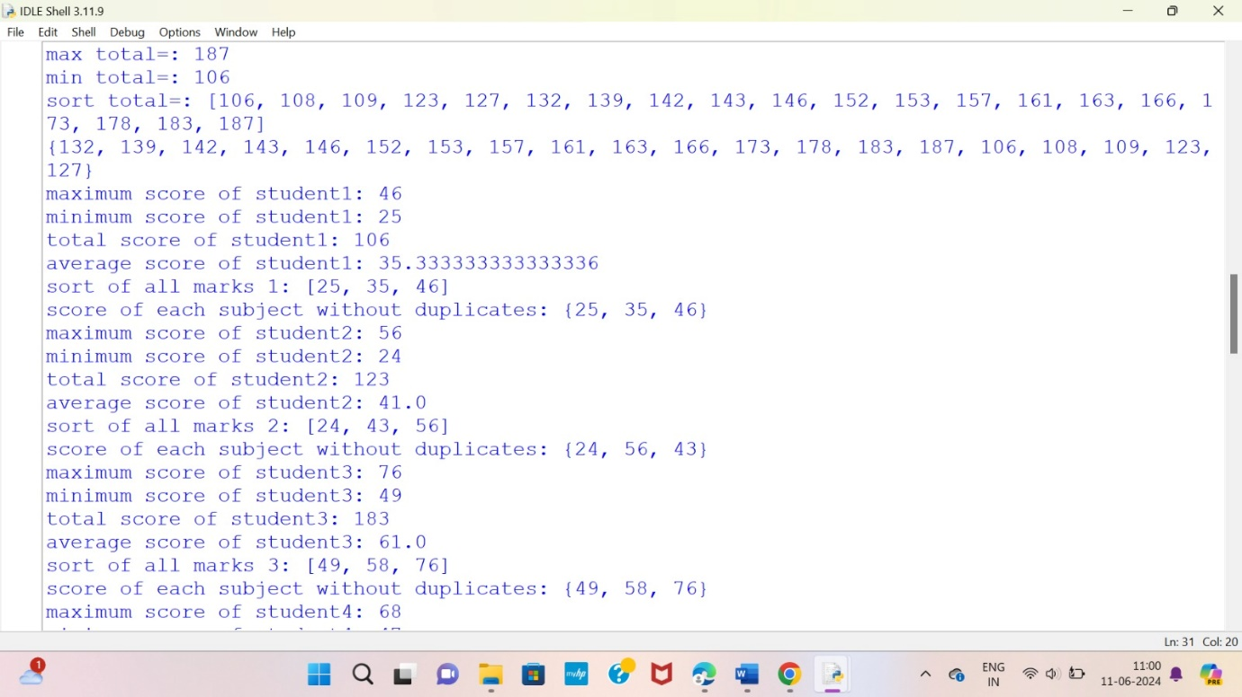

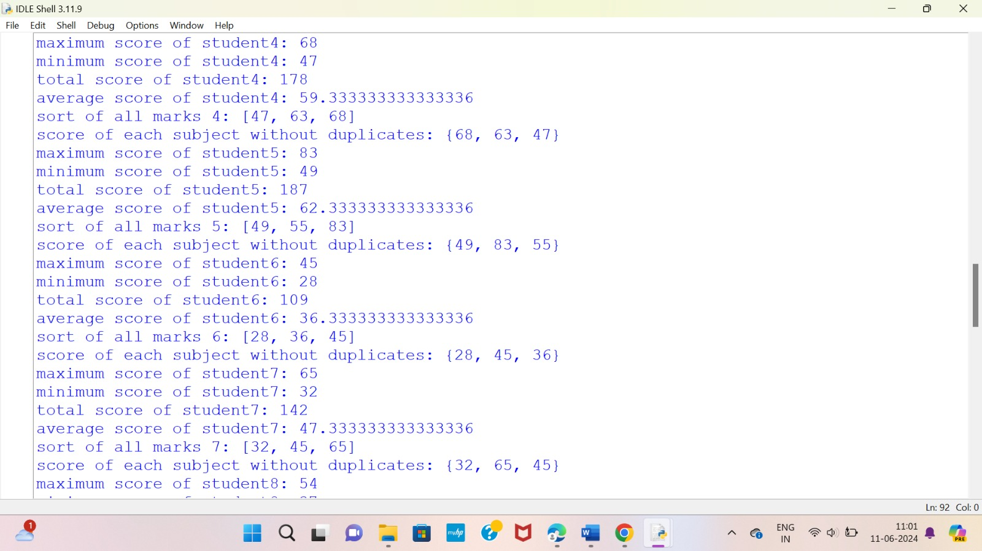

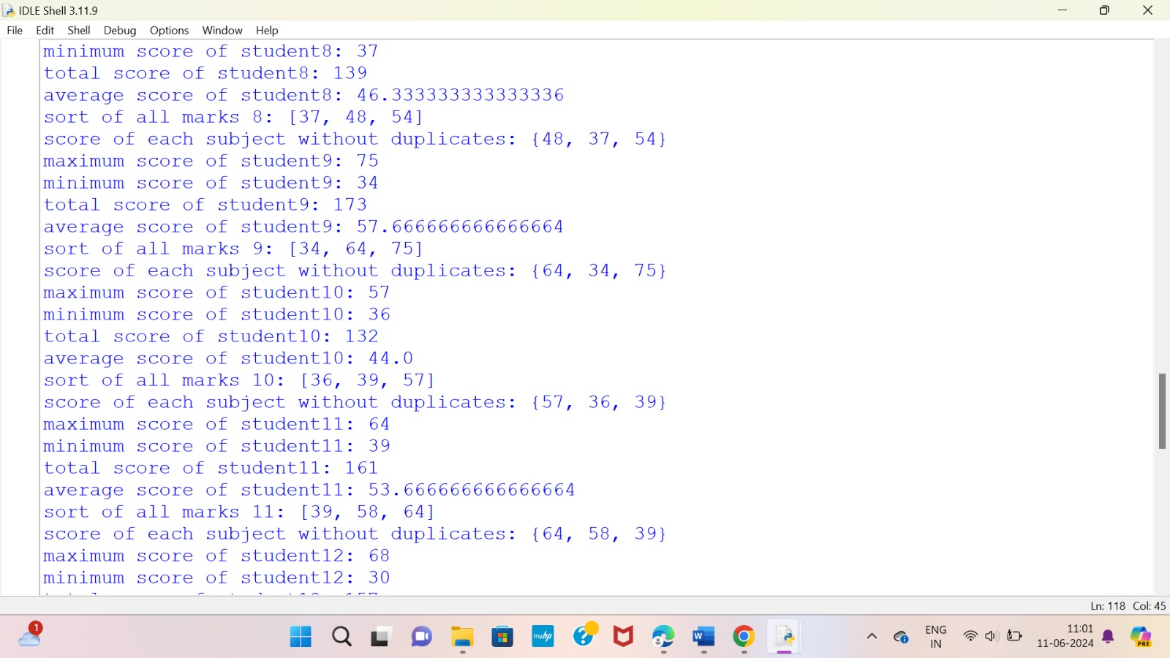

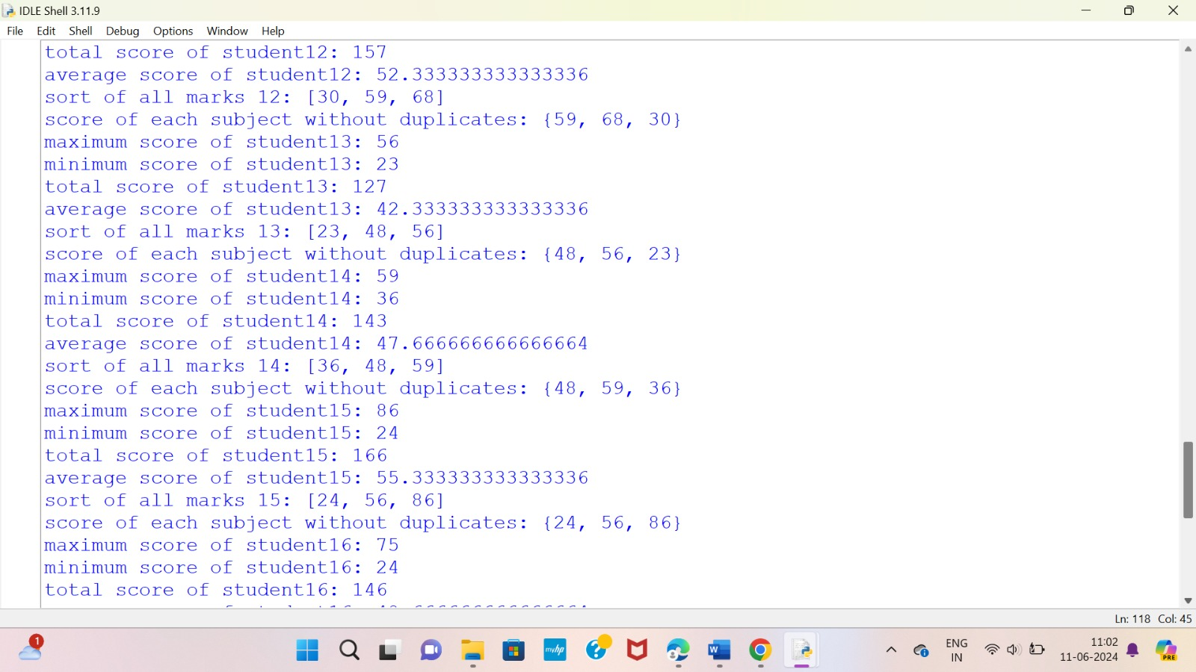

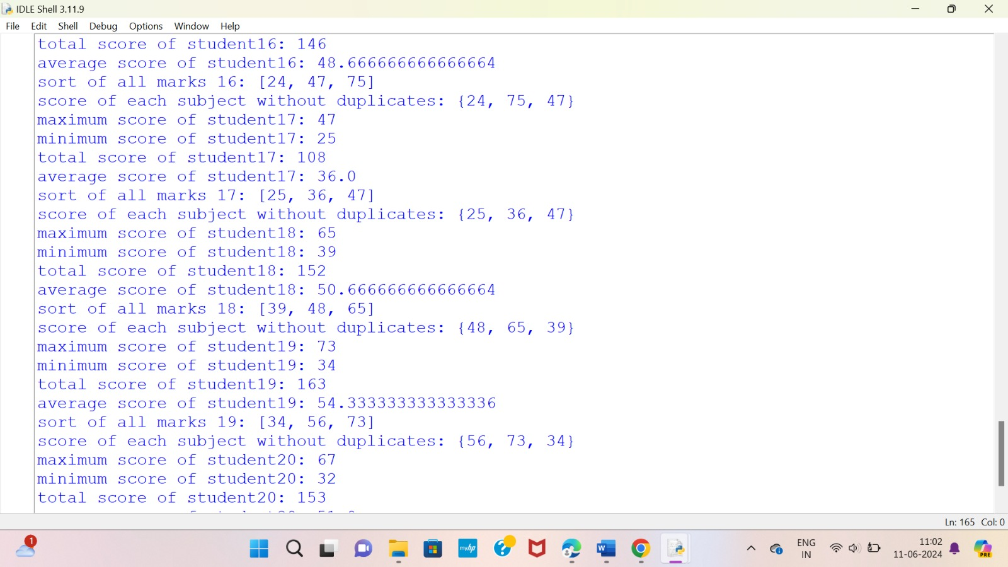

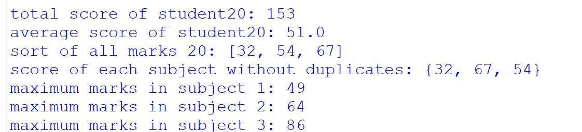

Explanation:

This code seems to be designed to handle student data, perform some calculations, and then display the results. Let me explain each part:

1. **Data Collection**:
   * The data function is defined to create a dictionary for each student with keys for name, roll number, marks, and total marks.
   * The s list is initialized to store these dictionaries.
2. **Input**:
   * The code prompts the user to input the number of students (n).
   * Then it iterates n times to input details for each student, including name, roll number, and marks in each subject.
3. **DataFrame Creation**:
   * After collecting the data, a Pandas DataFrame df is created from the list s containing student dictionaries.
4. **Calculations and Display**:
   * It finds the maximum, minimum, and sorted total marks of all students.
   * For each student:
     + It calculates the maximum, minimum, total, and average marks.
     + Sorts the marks in ascending order.
     + Displays the marks without duplicates using set.
   * It then finds the maximum marks in each subject across all students.

However, there are a few issues and points to note in the code:

* **Input Validation**: There's no validation of user input, which could lead to errors if unexpected input is provided.
* **Data Structure**: The data structure used (s list of dictionaries) might not be the most efficient or intuitive for handling this data. Using a dictionary with roll numbers as keys might be more natural.
* **Redundant Calculation**: In the loop where maximum marks in each subject across all students are calculated, marks is used without being defined in that scope. It seems like a logical error.
* **Clearing the List**: m.clear() is used to clear the list m, which might lead to issues as it empties the list for each subject, affecting subsequent calculations.
* **Print Formatting**: The formatting in print statements could be improved for better readability.

Conclusion:

* I concluded that this should can be used in scholastic achievement analytics with the proper requriment beyond the classroom, as they work closely with parents, community organizations, and policymakers to create a supportive ecosystem for student success. Through parent engagement initiatives, community partnerships, and advocacy efforts, scholastic achievement analysts help ensure that all students have access to the resources and support they need to thrive academically.